Social Media — Task Sheet
Instructions: Do not change the question text. Write your answer directly below each question. For Objective questions, the expected output columns and row counts are given below the question. For Subjective questions, no such details are given, work out and write the answer on your own.

Objective Questions
Q1 Are there any tables with duplicate or missing null values? If so, how would you handle them?
users — rows with NULL username
Output columns (in order): id, username, created_at (3 columns)
Row count: Varies — this is what O1 is asking you to determine. Run the query and report what you find.
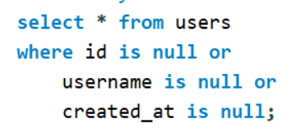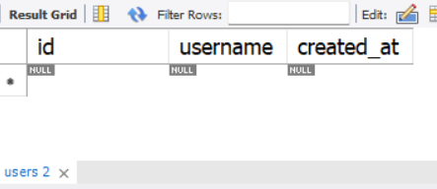
users — duplicate usernames
Output columns (in order): username, count (2 columns)
Row count: Varies — this is what O1 is asking you to determine. Run the query and report what you find.
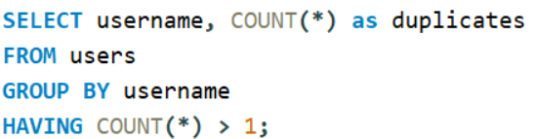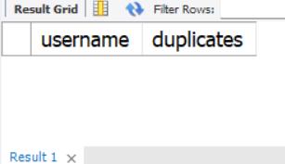
photos — rows with NULL image_url / user_id / created_dat
Output columns (in order): id, image_url, user_id, created_dat (4 columns)
Row count: Varies — this is what O1 is asking you to determine. Run the query and report what you find.
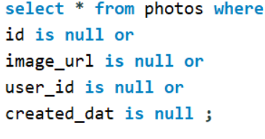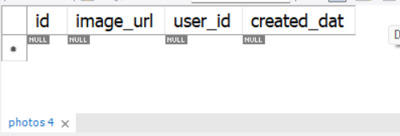
photos — duplicate (image_url, user_id) pairs
Output columns (in order): image_url, user_id, count (3 columns)
Row count: Varies — this is what O1 is asking you to determine. Run the query and report what you find.
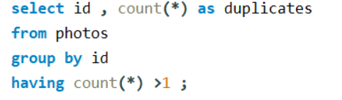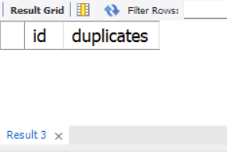
comments — rows with NULL comment_text / user_id / photo_id / created_at
Output columns (in order): id, comment_text, photo_id, user_id, created_at (5 columns)
Row count: Varies — this is what O1 is asking you to determine. Run the query and report what you find.
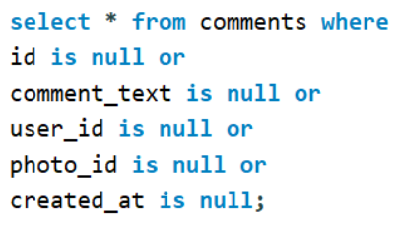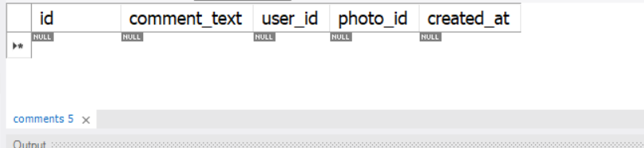
comments — duplicate (comment_text, user_id, photo_id) triples
Output columns (in order): comment_text, user_id, photo_id, count (4 columns)
Row count: Varies — this is what O1 is asking you to determine. Run the query and report what you find. 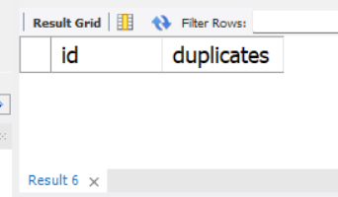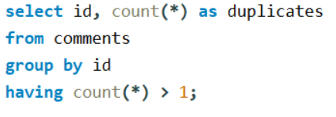
likes — rows with NULL user_id / photo_id / created_at
Output columns (in order): user_id, photo_id, created_at (3 columns)
Row count: Varies — this is what O1 is asking you to determine. Run the query and report what you find.

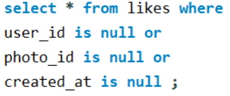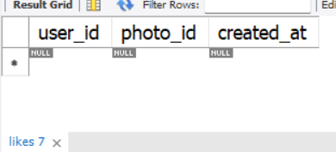
likes — duplicate (user_id, photo_id) pairs
Output columns (in order): user_id, photo_id, count (3 columns)
Row count: Varies — this is what O1 is asking you to determine. Run the query and report what you find.
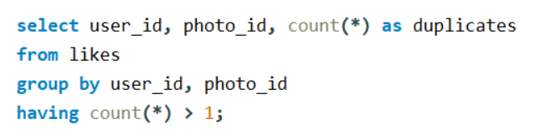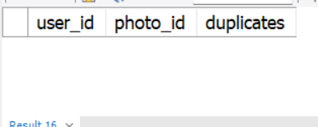
follows — rows with NULL follower_id / followee_id / created_at
Output columns (in order): follower_id, followee_id, created_at (3 columns)
Row count: Varies — this is what O1 is asking you to determine. Run the query and report what you find.

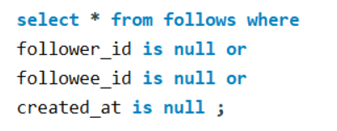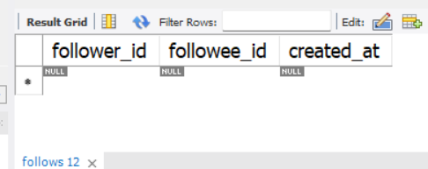
follows — duplicate (follower_id, followee_id) pairs
Output columns (in order): follower_id, followee_id, count (3 columns)
Row count: Varies — this is what O1 is asking you to determine. Run the query and report what you find.
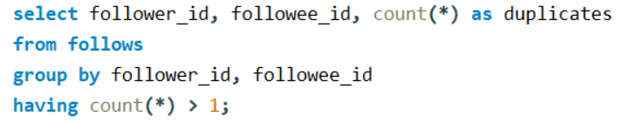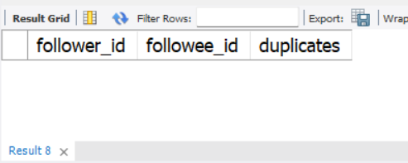

Approach: I used the IS NULL condition to check for missing values in different tables and columns. I also used GROUP BY with HAVING COUNT(*) > 1 to identify duplicate records based on specific columns.
Outcome: After checking the dataset, no duplicate records or NULL values were found. This indicates that the dataset is complete and consistent for further analysis.

Q2 What is the distribution of user activity levels (e.g., number of posts, likes, comments) across the user base?
Output columns (in order): user_id, username, total_posts, total_likes_given, total_comments_made (5 columns)
Row count: 100 rows (verified — 1 row per user).
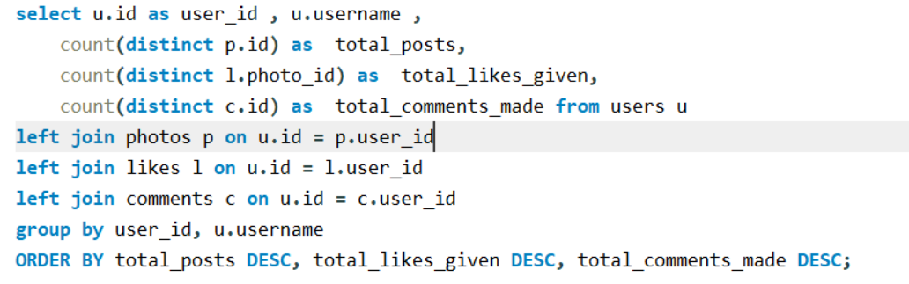
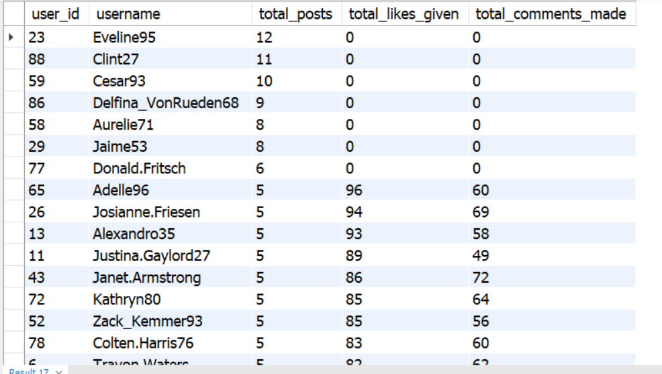
Approach: I used LEFT JOIN to combine the users, photos, likes, and comments tables. I used COUNT(DISTINCT) to calculate the total posts, likes given, and comments made by each user. I also used GROUP BY to group the results by user and ORDER BY to sort users based on their activity levels in descending order.
Outcome: The query returned 100 rows, with one row for each user. It shows the total posts, likes given, and comments made by every user, helping us compare activity levels across the user base.

Q3 Calculate the average number of tags per post (photo_tags and photos tables).
Output columns (in order): AverageTags (1 column)
Row count: 1 row (single aggregate value).

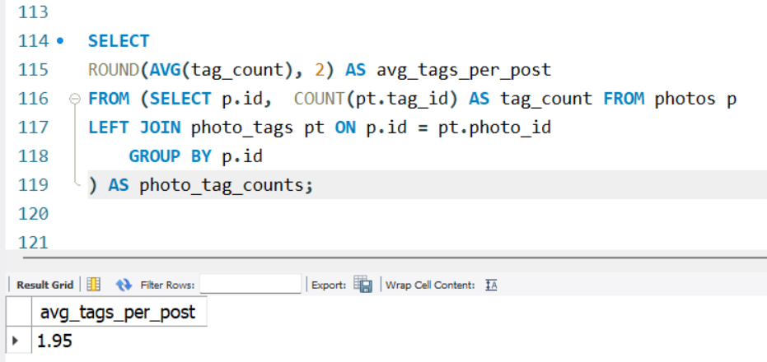
Approach: I used a subquery to count the number of tags associated with each post by joining the photos and photo_tags tables using LEFT JOIN. Then, I used the AVG() function to calculate the average number of tags per post and ROUND() to round the result to two decimal places.
Outcome: The query returned 1 row with an average of 1.95 tags per post. This helps to understand how many tags are used on posts on average.

Q4 Identify the top users with the highest engagement rates (likes, comments) on their posts and rank them.
Output columns (in order): user_id, Total, rnk (3 columns)
Row count: 74 rows (verified — 1 row per photo-owner whose photos have ≥1 like AND ≥1 comment).
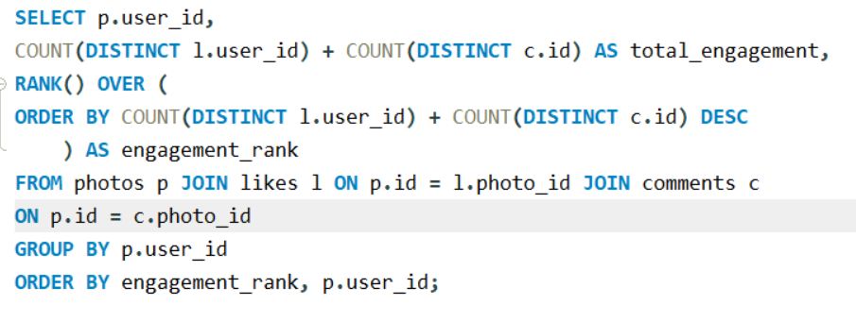
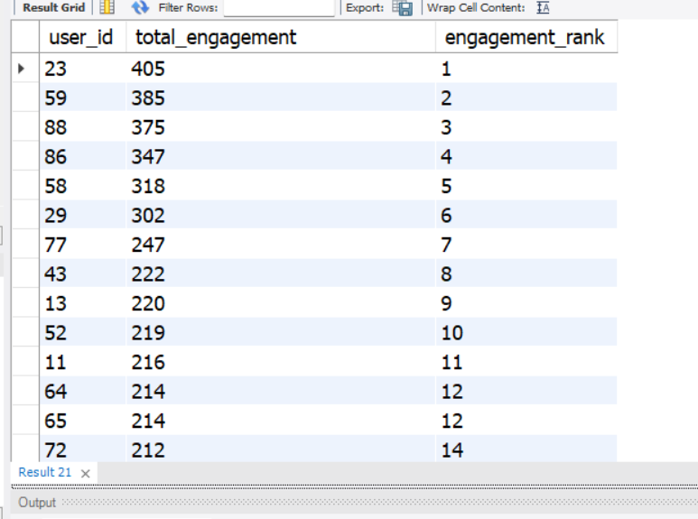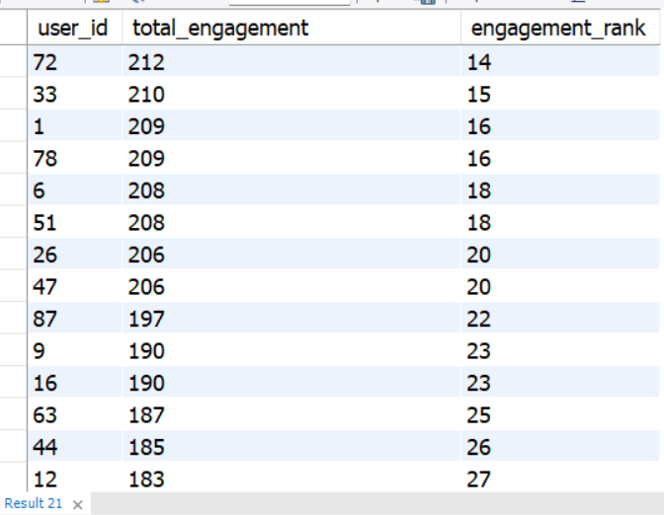

Approach: I used JOIN to combine the photos, likes, and comments tables. I used COUNT(DISTINCT) to calculate the total engagement likes and comments for each user. Then, I applied the RANK() window function to rank users based on their total engagement in descending order.
Outcome: The query returned 74 rows, ranking users whose posts have at least one like and one comment. It helps identify users whose posts receive the highest engagement.

Q5 Which users have the highest number of followers and followings?
Output columns (in order): user_id, username, followers, following (4 columns)
Row count: 100 rows (verified — 1 row per user).
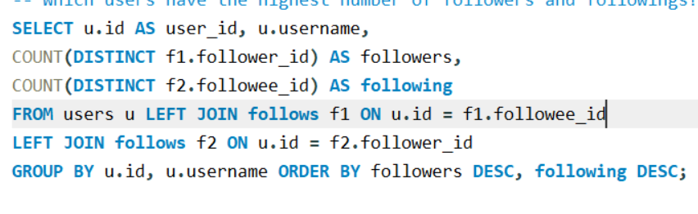
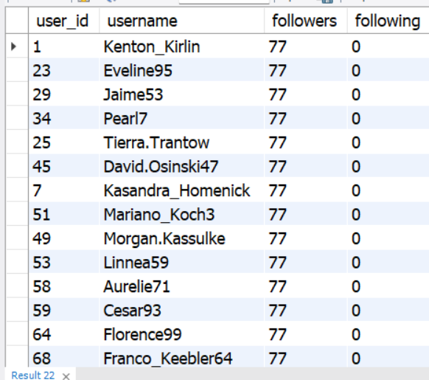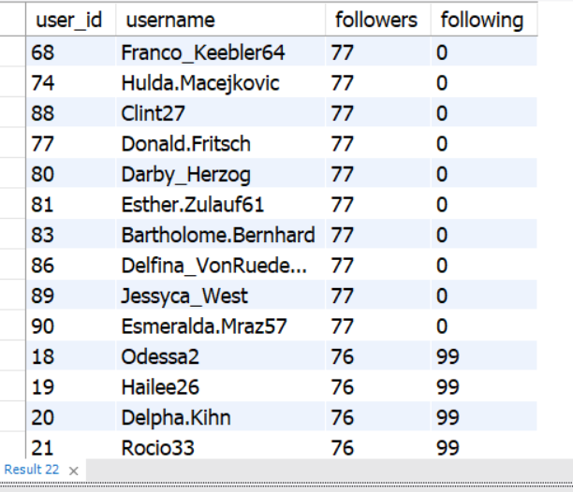
Approach: I used LEFT JOIN to connect the users and follows tables and COUNT(DISTINCT) to count followers and following for each user.
Outcome: The query returned 100 rows, showing each user's followers and following counts, sorted in descending order.

Q6 Calculate the average engagement rate (likes, comments) per post for each user.
Output columns (in order): id, username, avg_engagement (3 columns)
Row count: 74 rows (verified — 1 row per user who has posted ≥1 photo).

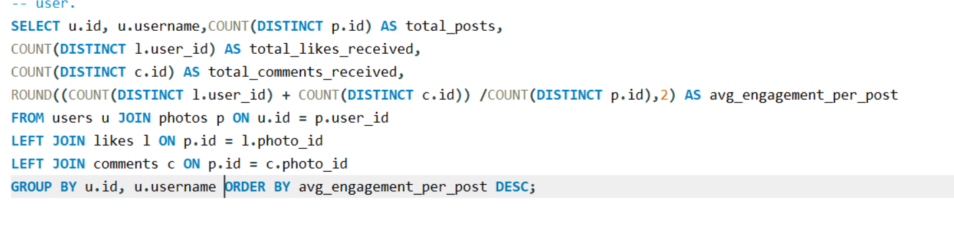
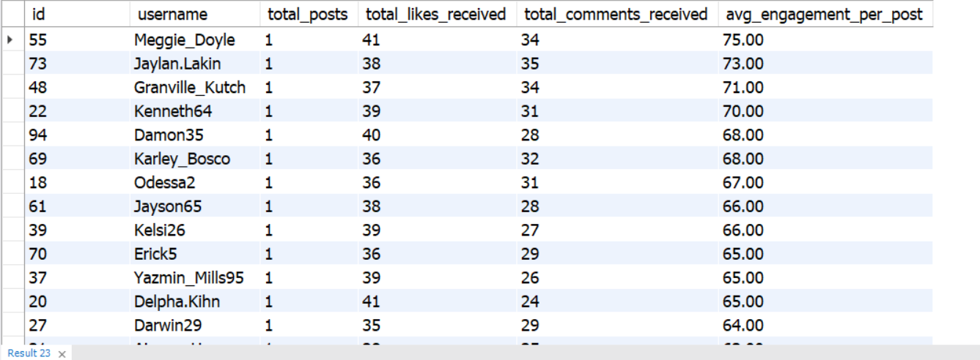
Approach: I used JOIN to connect the users, photos, likes, and comments tables. I calculated total engagement per post by dividing the total likes and comments by the number of posts.
Outcome: The query returned 74 rows, showing each user's average engagement per post, sorted from highest to lowest.

Q7 Get the list of users who have never liked any post (users and likes tables)
Output columns (in order): id, username (2 columns)
Row count: 23 rows (verified).
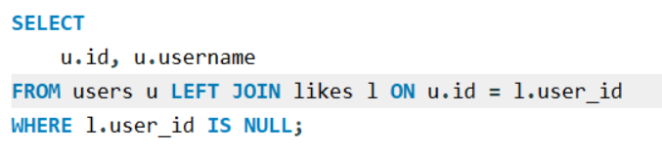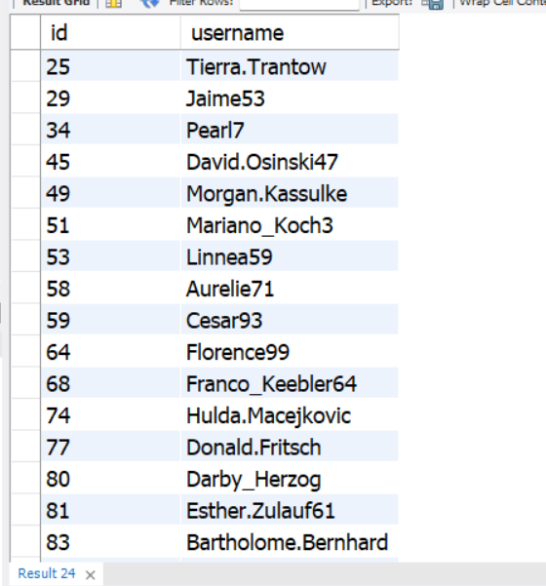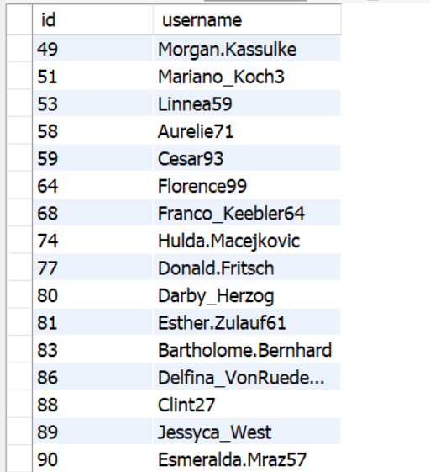
pproach: I used LEFT JOIN to connect the users and likes tables and the IS NULL condition to find users who have never liked any post.
Outcome: The query returned 23 rows, listing the IDs and usernames of users who have never liked a post.

Q8 How can you leverage user-generated content (posts, hashtags, photo tags) to create more personalized and engaging ad campaigns?
Output columns (in order): user_id, username, tag_name, tag_usage, total_likes_received, total_comments_received, total_engagement (7 columns)
Row count: 459 rows (verified — 1 row per user/tag combination that appears in that user's posts).
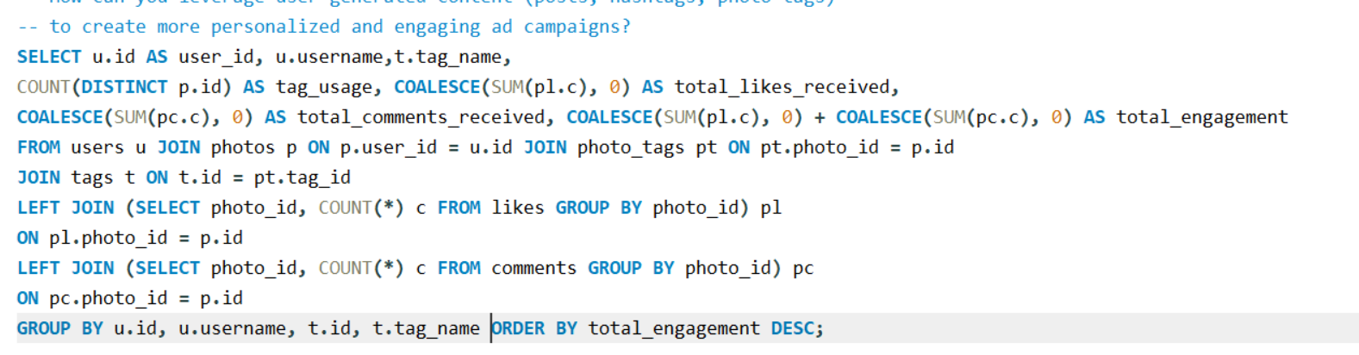
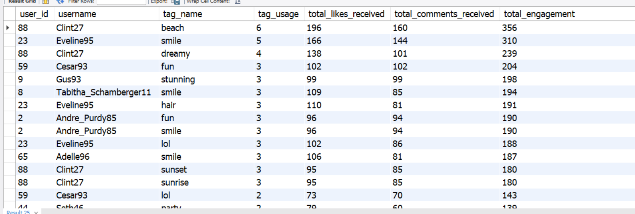
Approach: I used JOIN to connect the users, photos, photo tags, and tags tables. I used COUNT() to calculate tag usage and aggregated likes and comments to measure engagement for each user and hashtag combination.
Outcome: The query returned 394 rows, showing tag usage, likes, comments, and total engagement. This helps identify popular topics and create more personalized ad campaigns.

Q9 Are there any correlations between user activity levels and specific content types (e.g., photos, videos, reels)? How can this information guide content creation and curation strategies?
Output columns (in order): user_id, total_posts, total_likes, total_comments, total_engagement (5 columns)
Row count: 74 rows (verified — 1 row per user_id with ≥1 photo).
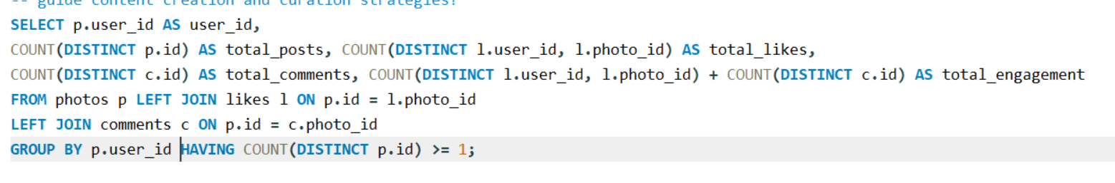
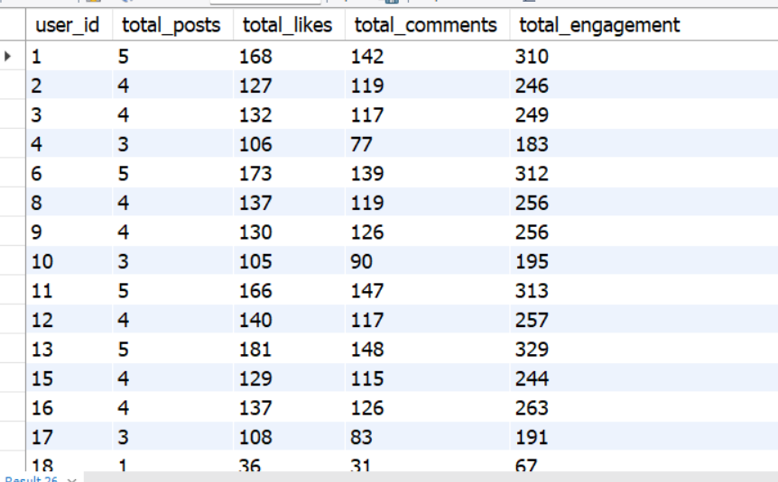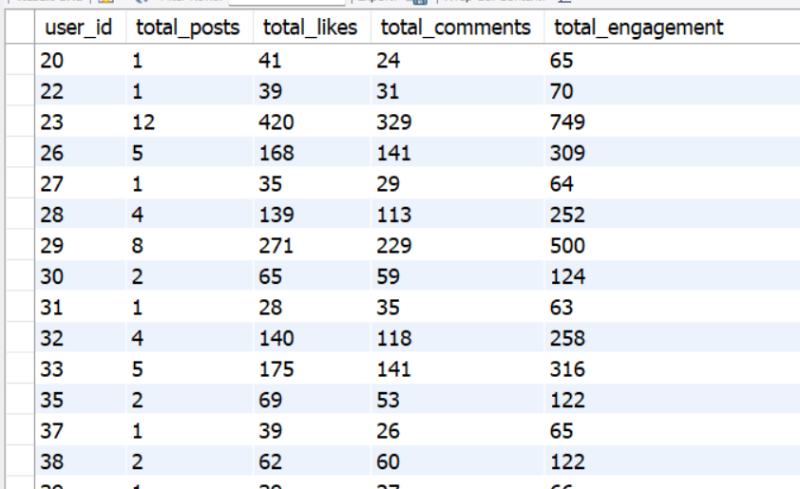
Approach: I used LEFT JOIN to combine the photos, likes, and comments tables. I used COUNT(DISTINCT) to calculate total posts, likes, and comments for each user, then calculated total engagement.
Outcome: The query returned 74 rows, showing each user's posts and engagement. This helps identify highly engaging users and understand their activity levels.

Q10 Calculate the total number of likes, comments, and photo tags for each user.
Output columns (in order): user_id, username, total_likes, total_comments, total_tags (5 columns)
Row count: 100 rows (verified — 1 row per user).

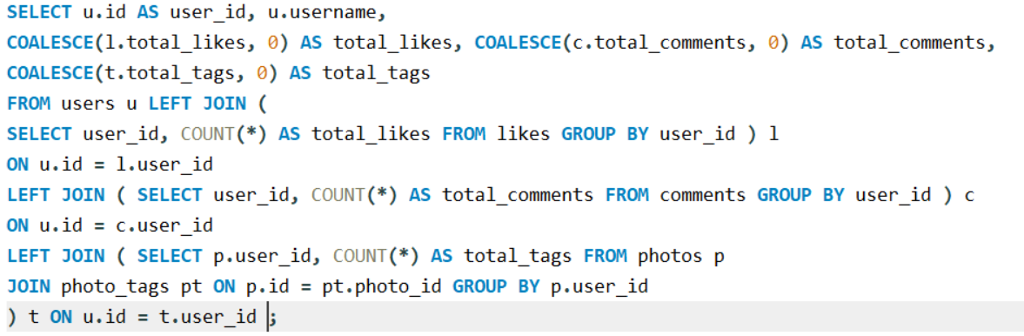
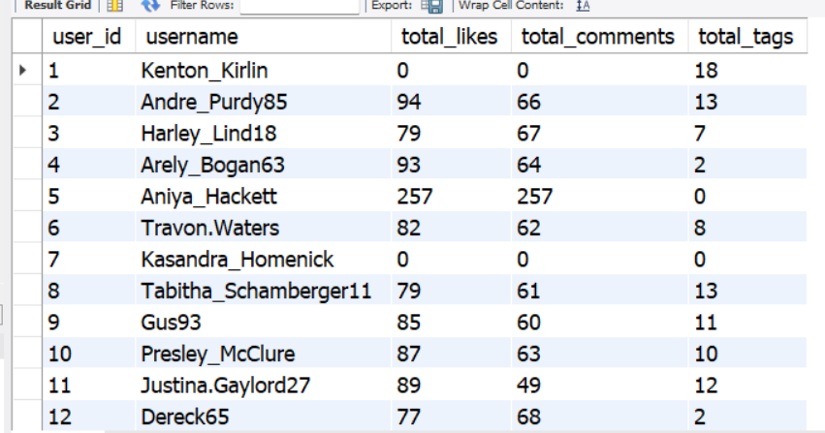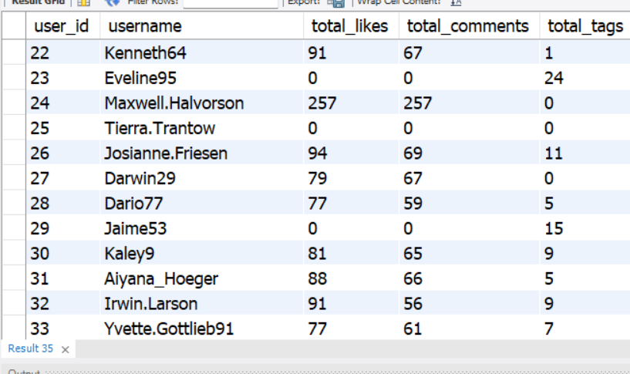
Approach: I used LEFT JOIN to combine the users, likes, comments, and photo tags data. I used COUNT() to calculate the total likes, comments, and tags for each user, and COALESCE() to display zero where no activity was found.
Outcome: The query returned 100 rows, showing each user's total likes, comments, and photo tags. This helps compare user engagement and identify users who are more active on the platform.

Q11 Rank users based on their total engagement (likes, comments, shares) over a month.
Output columns (in order): user_id, username, likes_given, comments_made, total_engagement, engagement_rank (6 columns)
Row count: 100 rows (verified — 1 row per user).

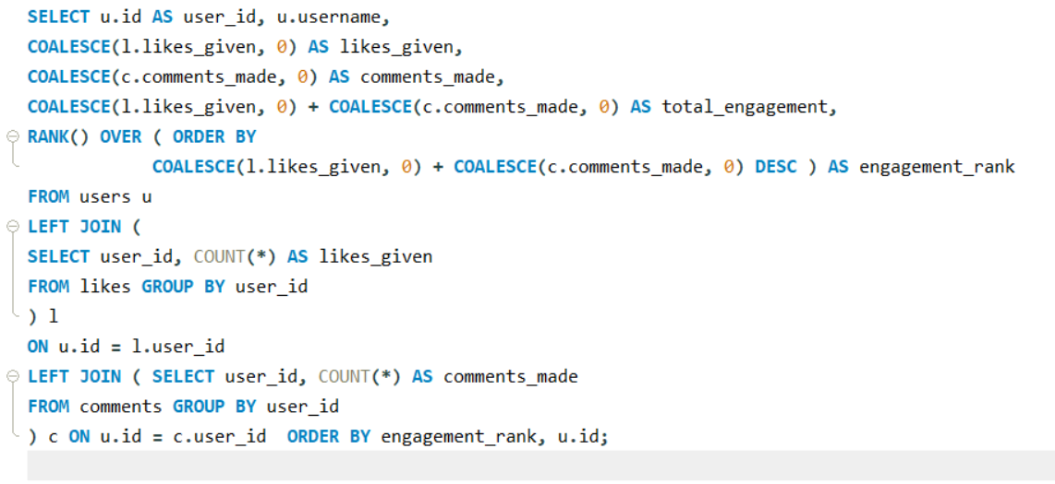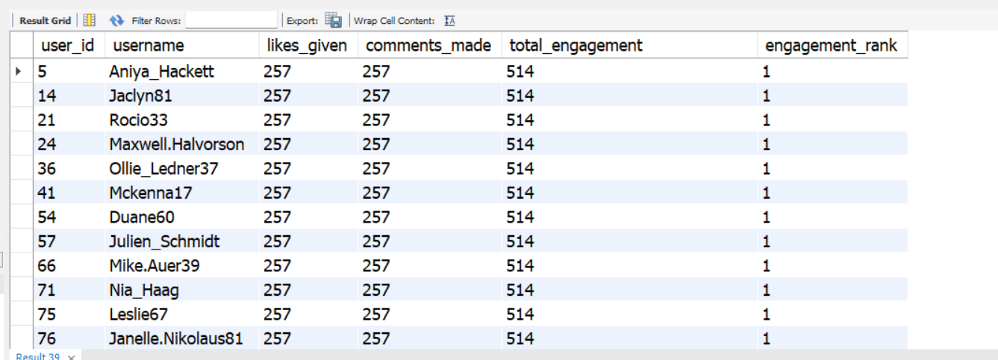
Approach: I used LEFT JOIN to combine the users, likes, and comments data. I used COALESCE() to handle NULL values, calculated total engagement by adding likes and comments, and applied the RANK() function to rank users in descending order of engagement.

Q12 Retrieve the hashtags that have been used in posts with the highest average number of likes. Use a CTE to calculate the average likes for each hashtag first.
Output columns (in order): tag_id, tag_name, avg_likes_per_photo, total_likes, total_photos (5 columns)
Row count: 10 rows (LIMIT 10; 21 tags exist in total, so the limit is reached).
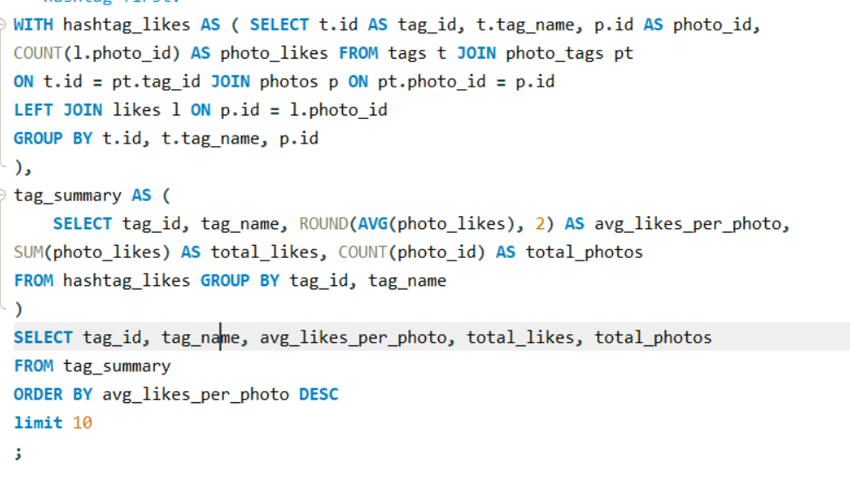
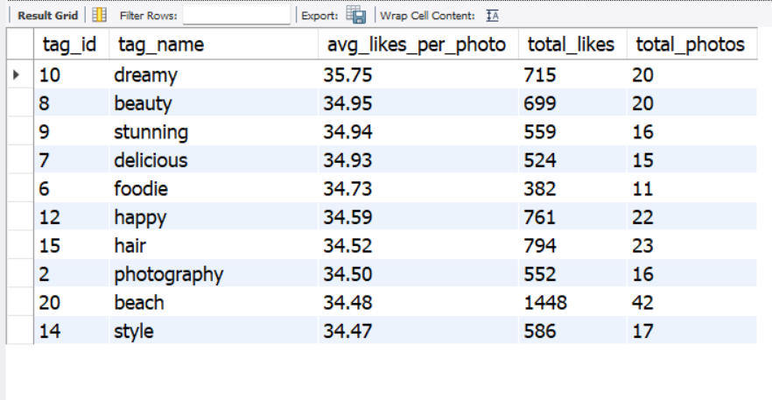
Approach: I used a CTE to calculate the number of likes for each photo associated with a hashtag. Then, I used AVG() to calculate the average likes per photo and SUM() to calculate total likes. Finally, I sorted the hashtags by average likes in descending order and selected the top 10.
Outcome: The query returned 10 rows, showing the hashtags with the highest average likes per photo. The hashtag #dreamy ranked first, with an average of 35.75 likes per photo, helping identify popular topics for content creation.

Q13 Retrieve the users who have started following someone after being followed by that person.
Output columns (in order): id, username (2 columns)
Row count: 77 rows (verified).
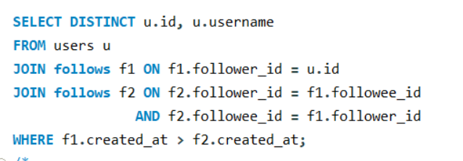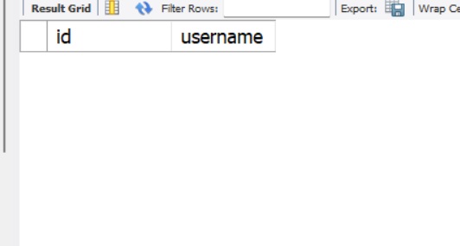
I used a self-join on the follows table to find users who follow each other. I then compared their created_at timestamps to identify who started following the other person later.
Outcome: The query returned 0 rows no records matched this specified conditions in the dataset.

Subjective Questions
Q1 Based on user engagement and activity levels, which users would you consider the most loyal or valuable? How would you reward or incentivize these users?
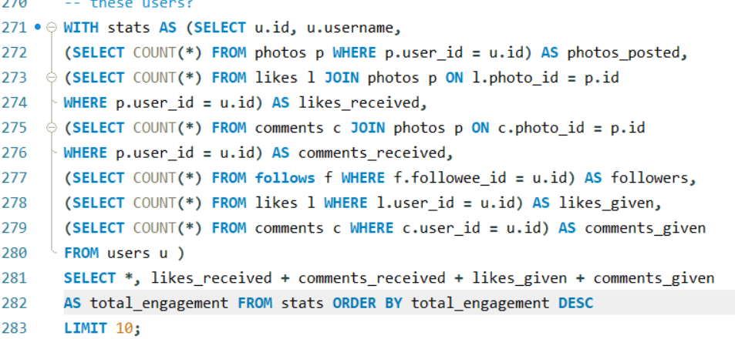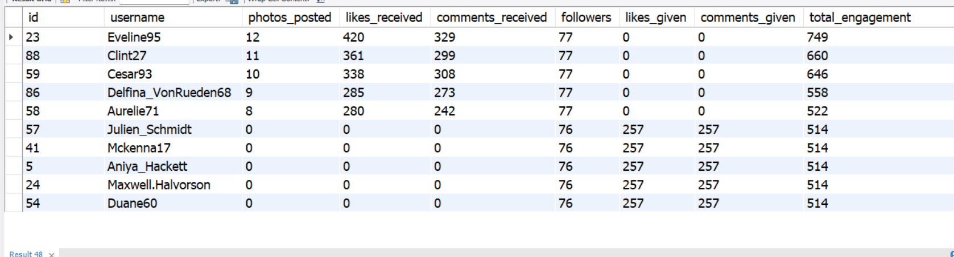

Approach: I used a CTE and subqueries to calculate users posts, likes and comments received, likes and comments given, and follower counts. Then, I calculated total engagement and sorted users in descending order.
Outcome: The results show that users who receive more likes and comments on their posts are valuable because their content attracts attention and interaction. Users who actively give likes and comments to others are also valuable because they contribute t the platform's engagement and build connections with other users. Both groups are important for the platform's growth. To reward them, the platfom can offer badges, recognition, exclusive features, rewards for active participation, and personalized recommendations. This can encourage users to rmain active, create more content, and continue interacting with the community.

Q2 For inactive users, what strategies would you recommend to re-engage them and encourage them to start posting or engaging again?
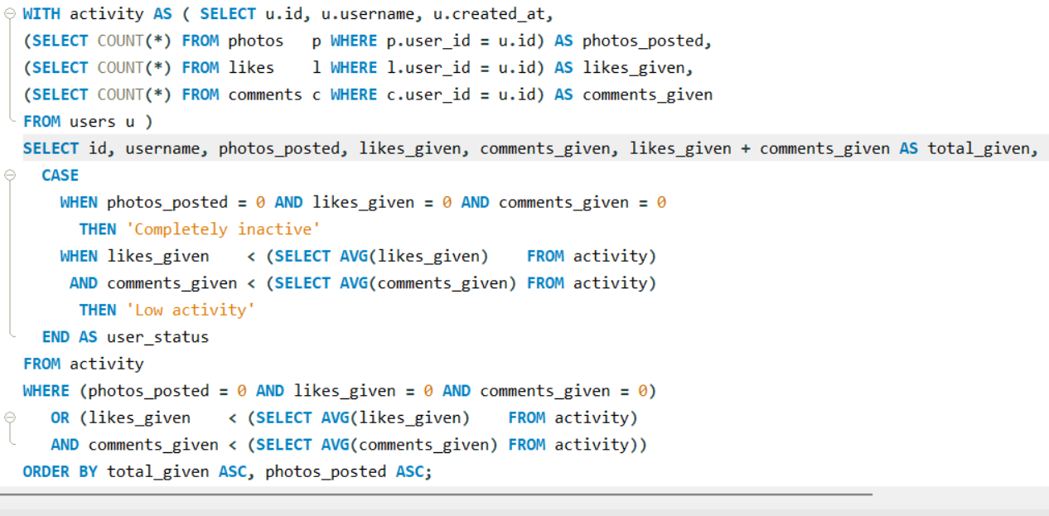

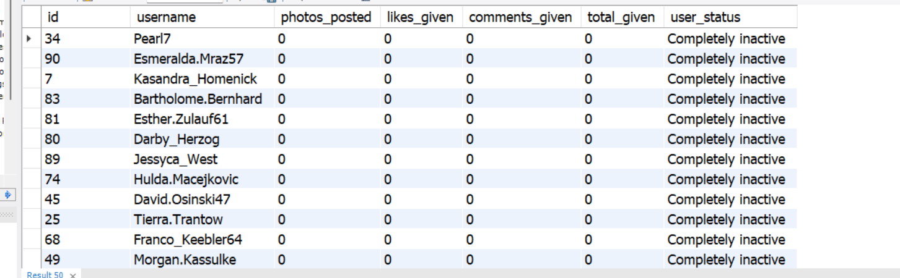
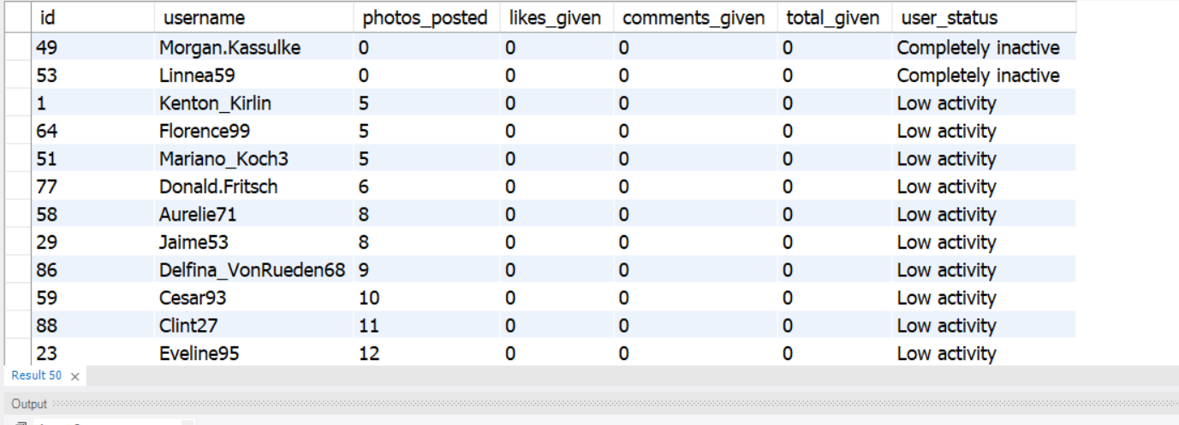
Approach: I used a CTE and subqueries to count each user's posts, likes given, and comments made. Then, I used a CASE statement to classify users as completely inactive or low activity.
Outcome: The results help identify users who are not actively using the platform To re engage completely inactive users, the platform can send personalized notifiations, suggest trending content, and encourage them to make their first post. For low-activity users, it can recommend posts based on their interests, remind them about friends' activites, and encourage them to like r comment on posts These strategies can increase user participation, improve engagement, and motivate users to become active again.

Q3 Which hashtags or content topics have the highest engagement rates? How can this information guide content strategy and ad campaigns?
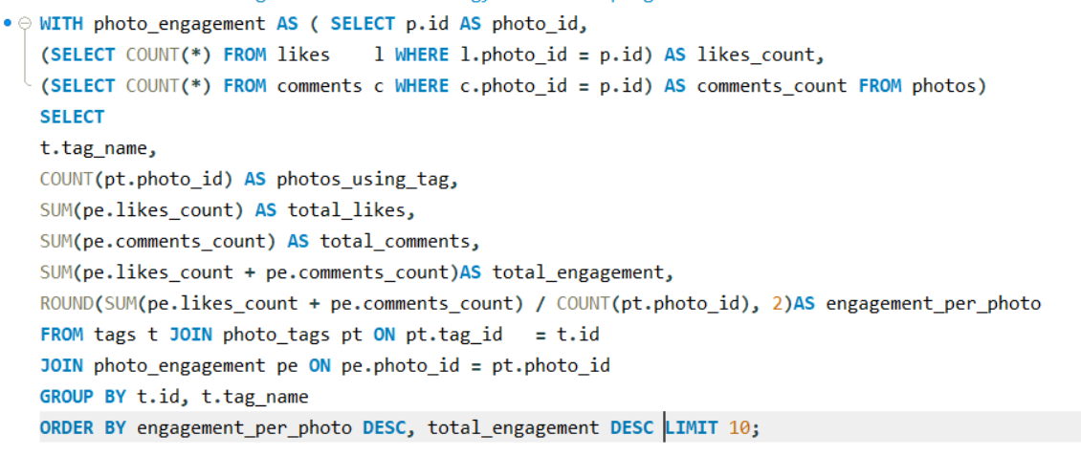
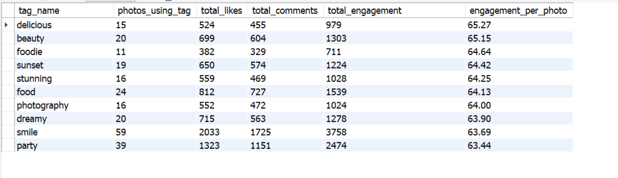
Approach: I used a CTE to calculate likes and comments for each photo, then grouped the results by hashtag and calculated the average engagement per photo. Finally, I sorted the hashtags in descending order and selected the top 10.
Outcome: The results show that #delicious has the highest average engagement, with 65.27 interactions per photo. Other popular hashtags include #beauty and #foodie. These insights can help the platform focus on popular topics, create relevant content, and design targeted ad campaigns to increase user engagement.

Q4 Are there any patterns or trends in user engagement based on demographics (age, location, gender) or posting times? How can these insights inform targeted marketing campaigns?
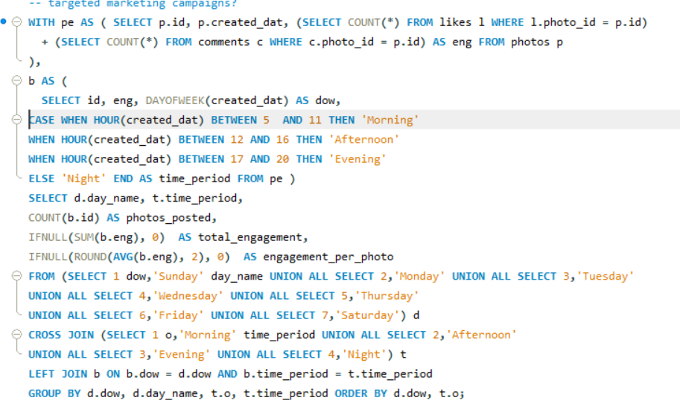
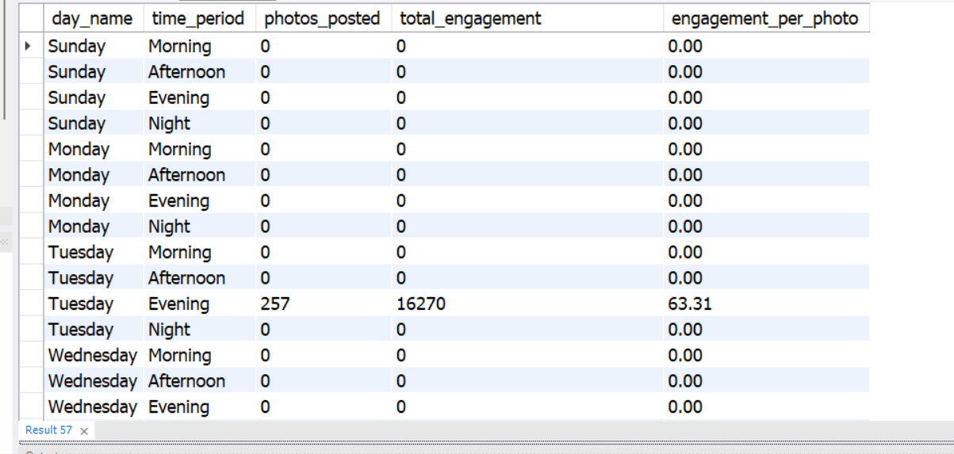
Approach: I used CTEs to calculate likes and comments for each photo, then grouped the results by day of the week and time period to measure engagement.
Outcome: The results show that all recorded engagement is concentrated on Tuesday evening, with 257 photos, 16,270 total interactons, and an average of 63.31 interactions per photo. All other displayed time slots show zero activity. This suggests Tuesday evening may be a suitable time to test posts nd targeted ad campaigns. However, since the data is concetrated in one time slot, more data is needed to confirm this trend. Age, location, and gender patterns cannot be analyzed because these details are not available in the given tables.

Q5 Based on follower counts and engagement rates, which users would be ideal candidates for influencer marketing campaigns? How would you approach and collaborate with these influencers?
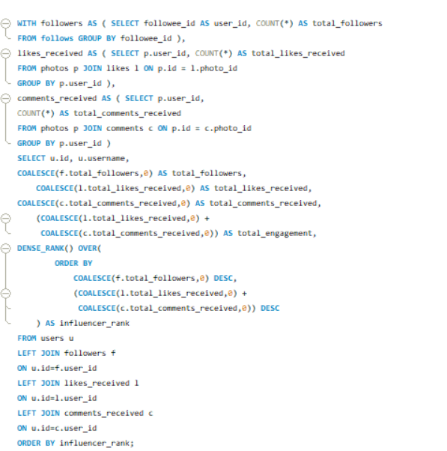
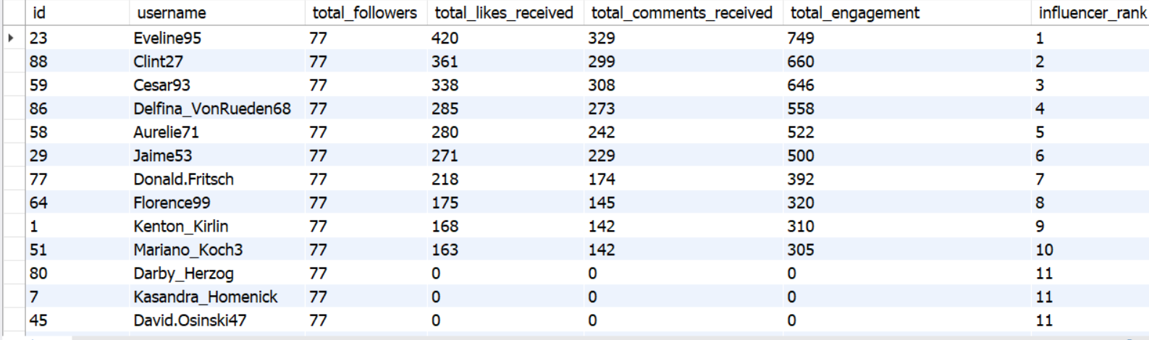
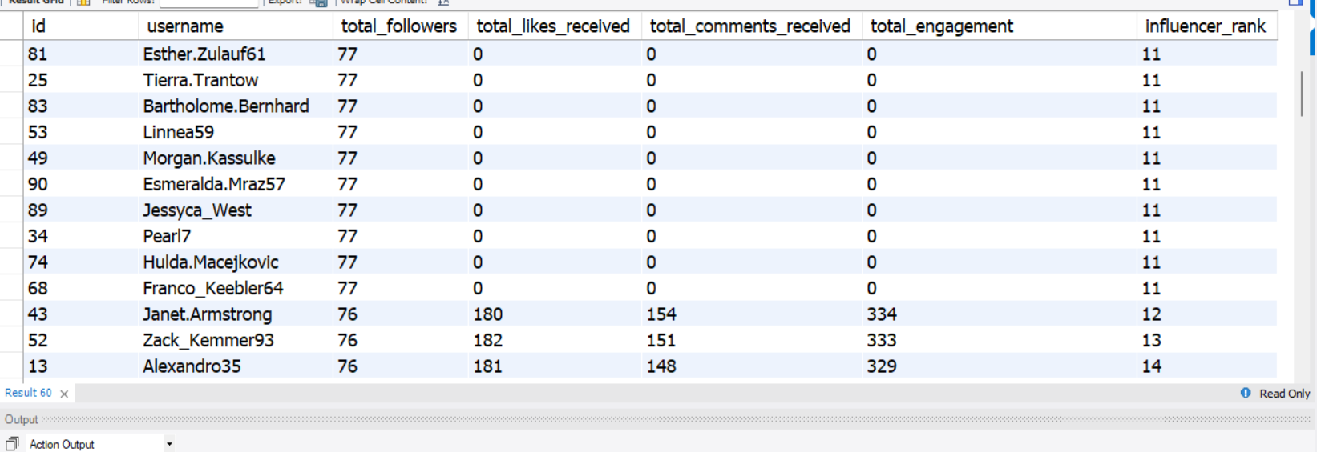

Approach: I used CTEs to calculate each user's followers, likes received, and comments received. Then, I calculated total engagement and used DENSE_RANK() to rank users based on followers and engagement.
Outcome: The results help identify potential influencers who have a large follower base and receive high engagement on their posts These users can be selected for influencer marketing campaigns to promote products or services. The platform can collaborate wth them through sponsored posts, product promotions, and special campaigns. This can help increase brand awareness, reach more users, and improve audince engagement.

Q6 Based on user behavior and engagement data, how would you segment the user base for targeted marketing campaigns or personalized recommendations?
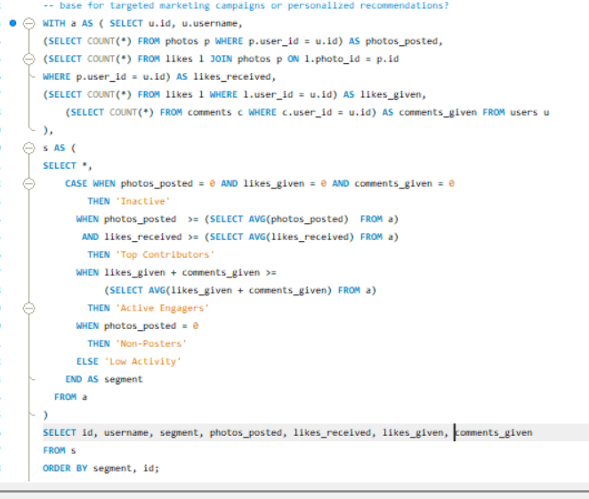
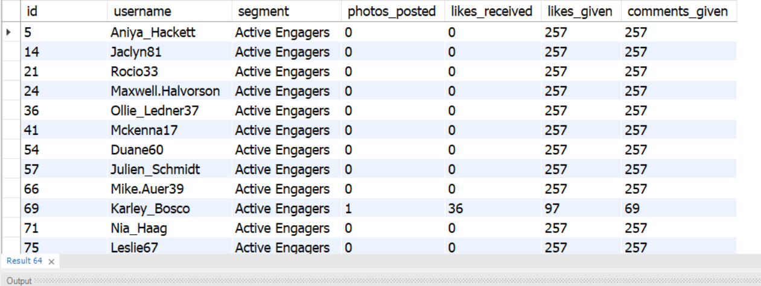
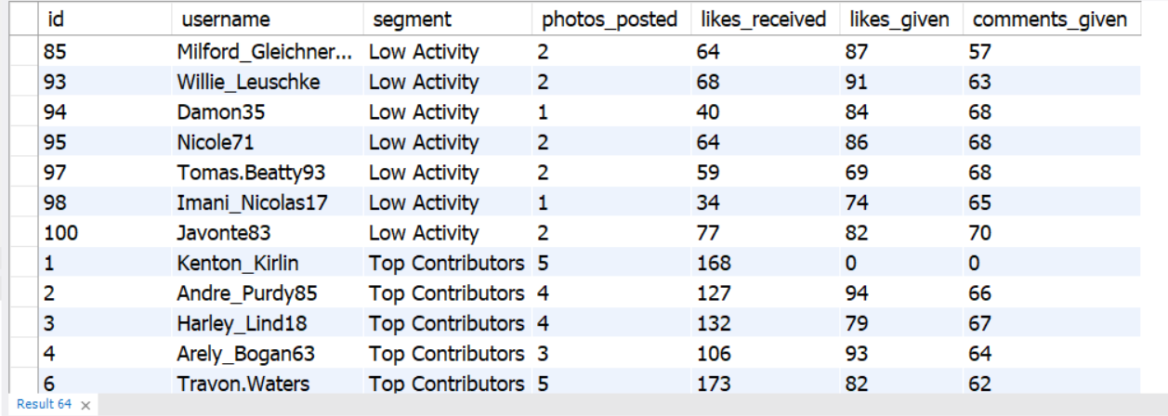
Approach: I used a CTE and subqueries to calculate each user's posts, likes received, likes given, and comments given. Then, I used a CASE statement to divide users into different segments based on their activity levels.
Outcome: The users were divided into five groups: Inactive, Top Contributors, Active Engagers, Non-Posters, and Low Activity. This segmentation helps the platform target each group differently. For example, inactive users can receive re-engagement notifications, active engagers can receive personalized recommendations, and top contributors can be rewarded for their participation. This can improve user engagement and retention.

Q7 If data on ad campaigns (impressions, clicks, conversions) is available, how would you measure their effectiveness and optimize future campaigns?
- Measure impressions: Check how many users saw the advertisement.
- Calculate Click Through rate : divide clicks by impressions
- Calculate Conversion Rate: Divide conversions by clicks to measure how many users took the desired action.
- Compare campaigns: Identify which campaigns generate the most clicks and conversions.
- Optimize future campaigns: Focus on successful ads, improve underperforming ads, and target the most relevant audience.
- Monitor results: Regularly track performance and adjust the campaign strategy to improve effectiveness.

Q8 How can you use user activity data to identify potential brand ambassadors or advocates who could help promote Instagram's initiatives or events?
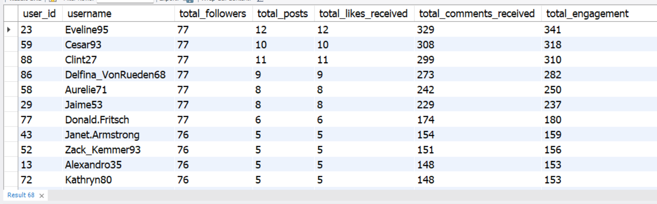
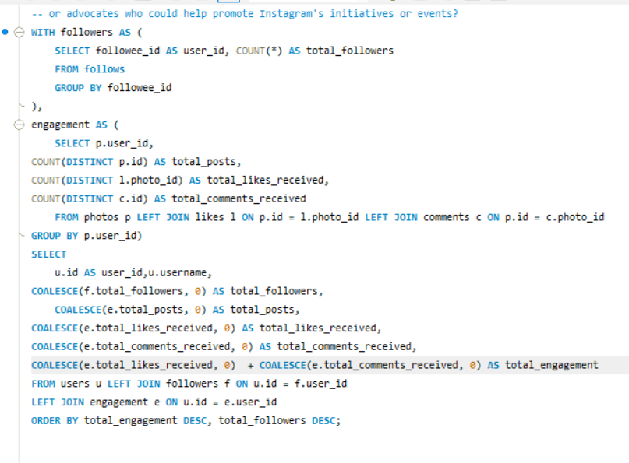
Approach: I used CTEs to calculate each user's followers, posts, likes, and comments. I combined the results using LEFT JOIN, calculated total engagement, and sorted users by engagement and follower count to identify potential brand ambassadors.
The query provides a complete overview of each user's followers, posts, likes received, comments received, and total engagement. Users with high total engagement attract more interactions on their content and may be suitable for promoting Instagram's initiatives and events. Users with a large number of followers can help campaigns reach a wider audience. Users with both a large follower base and high engagement are promising candidates because they combine audience reach with audience interaction. The results can help Instagram shortlist users for promotional campaigns, sponsored posts, and event promotions. The platform can use these insights to improve brand awareness and encourage more users to participate in its initiatives.

Q9 How would you approach this problem, if the objective and subjective questions weren't given?
- I would first read the data dictionary to understand the dataset, its tables, columns, and relationships.
- I would check for missing values, NULL values, and duplicate records and correct them wherever necessary.
- I would explore the data using SQL quries to understand user activity, posts, likes, comments, and followers.
- I would identify the main business objectives, such as improving user engagement, retention, and platform growth.
- I would calculate important KPIs, such as total posts, average engagement per post, and active users.
- I would analze patterns to identify popular hashtags, highly engaged users, and inactive users.
- I would segment users based on their activity and engagement levels.
- I would identify trends and insights that could help explain user behavior.
- I would provide recommendations to improve engagement, re-engage inactive users, and create personalized campaigns.
- Finally, I would sumarize the findings in a report or dasboard to help the business make data-driven decisions.

Q10 Assuming there's a "User_Interactions" table tracking user engagements, how can you update the "Engagement_Type" column to change all instances of "Like" to "Heart" to align with Instagram's terminology?
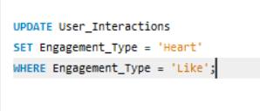

used the UPDATE statement to modify existing records in the User_Interactions table.
I used SET to change the Engagement_Type value from 'Like' to 'Heart'.
I applied the WHERE clause to update only the rows where Engagement_Type = 'Like'
All instances of 'Like' are replaced with 'Heart', while other engagement types remain unchanged. This maintains consistent terminology in the database.

